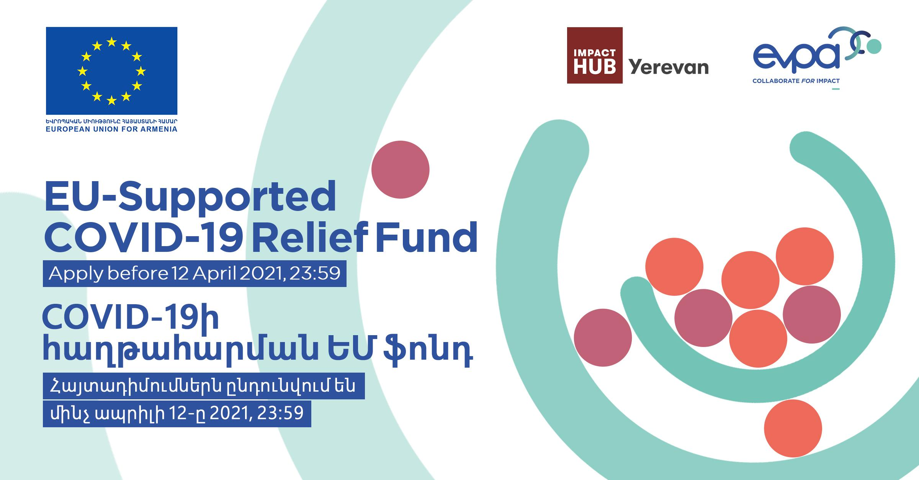

EU-SUPPORTED COVID-19 RELIEF FUND
APPLICATION FORM
By applying for this grant opportunity, I, as responsible for this organisation confirm its agreement of the following conditions, if awarded the grant:
- Grant recipients must comply with reporting requirements (both narrative and financial, with supporting documents) for the project, including providing relevant documentation, in a timely manner.
- Grant recipients must complete implementation (including incurring all costs for the items requested in the budget) by 15 December 2021.
- Grant recipients could be offered only part of the funding requested. In such cases, negotiations will be conducted with the grantee organisation on priority activities.
- Grant recipients will be invited to a compulsory training session (maximum up to 2 days) in May-June 2021 on social impact measurement and reporting.
  - Grant recipients must agree to develop a social impact monitoring plan during this training session, which they will use from July 2021 to June 2022 to measure and provide data to Impact Hub Yerevan on the impact of their social enterprise.
  - Grant recipients should be open and accept monitoring visits from July 2021 to June 2022 by Impact Hub Yerevan and possibly The EU Delegation to Armenia or their representatives (e.g. consultants), which will involve an assessment of grant implementation, profitability and performance of the social enterprise as well as its social impact.
- Grant recipients must publicly announce to beneficiaries that activities are funded by the European Union and comply with the “Collaborate for Impact” project communication and visibility guidelines and ensure EU visibility on purchased equipment, at project sites and in other relevant ways.
- All information provided in the application form is true and any information that has been falsified or withheld will result in the annulment of the decision to provide the grant, in case the application was initially considered successful.

SUMMARY TABLE
Name of applicant organisation:
Name of representative:
The legal status of applicant organisation:
Date of registration of applicant organisation:
Tax code of applicant organisation:
Address of applicant organisation:
Online presence of applicant organisation (website, social media page(s)):
Total project value (AMD):
Co-funding contribution (AMD):
(not mandatory, but desirable)
Total amount requested from donor (AMD):

PERSONAL DETAILS OF APPLICANT REPRESENTATIVE
Name of representative:
Email address of representative:
Phone number of representative:
Residential address of representative:
Alternative contact name at organisation:
Email address of alternative contact:
Phone number of alternative contact:

1. What is the mission of your social enterprise? (up to 100 words)
What social problem are you trying to solve or which vulnerable group do you serve? How do you improve the lives of your beneficiaries or society in general?
2. Which Sustainable Development Goal(s) are the focus of your social enterprise (select at least one, or all that apply)?
- No Poverty
- Zero Hunger
- Good Health and Well-being
- Quality Education
- Gender Equality
- Clean Water and Sanitation
- Affordable and Clean Energy
- Decent Work and Economic Growth
- Industry, Innovation and Infrastructure
- Reduced Inequality
- Sustainable Cities and Communities
- Responsible Consumption and Production
- Climate Action
- Life Below Water
- Life on Land
- Peace and Justice Strong Institutions
- Partnerships to achieve the Goal

3. Which EU EaP priority is the focus of your social enterprise?
Select one or more of the four options below. For more details on the four priority areas and their relevance to Armenia, see this factsheet.
- Stronger Economy (economic development and market opportunities);
- Stronger Governance (strengthening institutions and good governance);
- Stronger Connectivity (connectivity, energy efficiency, environment and climate change);
- Stronger Society (mobility and people-to-people contacts).

4. Briefly describe the team that works in your social enterprise (up to 100 words)
Please provide bullet points with the name and role of each team member.
5. Who else does your work empower? (up to 100 words)
Please describe any other individuals or groups, both vulnerable and non-vulnerable, that benefit from your activities.
6. What products/services do you sell and when did you start offering them in the market? Please describe your sales performance up to March 2020. If you were not operational in March 2020, please answer where applicable (up to 200 words)
Please make sure you cover –
- All the different product/services you offer
- The date when your first sale occurred
- Figures for the amounts sold and revenue earned (confirmed by the financial evidence requested at the end of this form) -
  - From March 2019 to March 2020 or from the first sale to March 2020 if operations started after March 2019
  - After March 2020 to date (or till suspension/closure of business, if applicable)

7. How did COVID-19 impact your business? (up to 200 words)
Please provide specific issues that came up because of the pandemic, lockdown, and other related occurrences. Explain how your business may have developed if not for these unexpected developments.
8. What steps did you take to reduce the impact of COVID-19 on your business? What other support, if any, did you receive in this period? (up to 200 words)
Please provide details on your steps to address the crisis (even if they were not successful) and on all kinds of support that you received, even if it did not have the expected impact. In case you were unable to take any steps, please explain why this was not possible in your situation.
9. Please describe the social impact achieved by your social enterprise so far in the table below. If you were not operational in March 2020, please describe your expected social impact.
The text in red below is provided simply as an example. Please replace it with your own data.
Item | Number | Unit | Evidence | Comments
People with disabilities employed | 5 | People | See financial report | We started in 2018 with 3 people with disabilities and hired two more in 2019
Increased average monthly income of people with disabilities | 50 | Percent | See financial report | Before being hired at our company, our beneficiaries were receiving only the disability pension, which is XX,XXX AMD
…. | … | … | … | …

10. How do you mainstream gender equality and disability? (up to 200 words)
Please describe if/how your social enterprise provides training and income opportunities to marginalized groups, or allows them to gain access to services/resources that were otherwise out of their reach.
11. How do you work on mainstreaming Green Deal issues? Do you contribute to greening Armenia? (up to 100 words)
Please describe if/how your social enterprise contributes to environmental conservation in Armenia.
12. Please complete the table below on your approximate revenue and profit forecasts for the second half of 2021 and the first half of 2022 if you receive the grant amount and conditions around COVID-19 in Armenia remain similar to the period of February-April 2021.
The text in red below is provided simply as an example. Please replace it with your own data.
 | 2021 (AMD) |  |  |  |  |  | 2022 (AMD)
 | Jul | Aug | Sep | Oct | Nov | Dec | Jan | Feb | Mar | Apr | May | Jun
Revenue
Sale of souvenirs | 200,000 | 400,000 | 400,000 | 100,000 | 100,000 | 100,000 | 100,000 | 100,000 | 200,000 | 200,000 | 200,000 | 200,000
Master classes | 100,000 | 150,000 | 200,000 | 50,000 | 50,000 | 0 | 0 | 0 | 50,000 | 50,000 | 50,000 | 100,000
Costs
Raw material | 30,000 | 60,000 | 60,000 | 10,000 | 10,000 | 10,000 | 10,000 | 10,000 | 30,000 | 30,000 | 30,000 | 30,000
Rent | 50,000 | 50,000 | 50,000 | 50,000 | 50,000 | 50,000 | 50,000 | 50,000 | 50,000 | 50,000 | 50,000 | 50,000
Salaries | 100,000 | 100,000 | 100,000 | 100,000 | 100,000 | 100,000 | 100,000 | 100,000 | 100,000 | 100,000 | 100,000 | 100,000
Utilities | 20,000 | 20,000 | 20,000 | 20,000 | 20,000 | 20,000 | 20,000 | 20,000 | 20,000 | 20,000 | 20,000 | 20,000
Profit | 100,000 | 320,000 | 370,000 | -30,000 | -30,000 | -80,000 | -80,000 | -80,000 | 50,000 | 50,000 | 50,000 | 100,000

13. Please complete the table below on the budget for your requested grant amount.
Please note that the budget should be between 5 to 9 million AMD. We expect the average grant amount per organisation to be around 6.2 million AMD but we are ready to provide larger grants for organisations that have greater needs if they have above-average social impact and business performance.
Please note that implementation must be complete (including incurring all costs for the items requested in the budget) by 15 December 2021.
The text in red below is provided simply as an example. Please replace it with your own data.
Item No. | Item | Quantity | Unit | Unit value (AMD) | Own contribution (AMD) | Other contribution (AMD) | Grant amount requested (AMD) | Total value (AMD)
1. | Laser cutting machine | 1 | machine | 250,000 | 0 | 0 | 250,000 | 250,000
2. | Packaging paper | 50 | kg | 2,000 | 20,000 | 0 | 80,000 | 100,000
3. | Assistant salary | 6 | months | 70,000 | 200,000 | 0 | 220,000 | 420,000
4. | … | … | … | … | … | … | … | …
5. | … | … | … | … | … | … | … | …
6. | … | … | … | … | … | … | … | …
 | TOTAL

14. Please complete the table below on the justification for each budget item. Note that at least 20% of the total budget must consist of items with a medium-to-long-term timeline.
The text in red below is provided simply as an example. Please replace it with your own data.
Item No. | Item | Will this budget item support your social enterprise in the a) short-term or b) medium-to-long term | Please provide details of how this will support your social enterprise (influence the social impact of the organisation?)
1. | Laser cutting machine | Medium-to-long term | This will allow us to reduce our souvenir production costs and produce in greater volume
2. | Packaging paper | Short-term | We will need to package our products before they are sold in shops and need to cover this raw material for a certain period until our revenues reach pre-COVID levels
3. | Assistant salary | Short-term | We were forced to fire our assistant when we could not pay salaries due to COVID. We would like to rehire him and need to cover his salary for 6 months until our revenues reach pre-COVID levels
4. | … | … | …
5. | … | … | …
6. | … | … | …

15. Please complete the table below for the 3 most recent grants or donations received by your organisation (if applicable).
The text in red below is provided simply as an example. Please replace it with your own data.
Item No. | Donor | How much was donated (including currency)? | When was this donation provided? | What was this donation used for?
1. | AGBU | 1,000,000 AMD | April 2020 | Purchase of new equipment and packaging material
2. | Government support | 100 EUR | May 2019 | One salary during lockdown
3. | … | … | … | …

16. Please complete the table below for the contacts of 4 partners or supporters that we can contact to learn more about your organisation.
The text in red below is provided simply as an example. Please replace it with your own data.
Item No. | Organisation name | Contact person | Position | E-mail | Phone number
1. | AGBU | Poghos Poghosyan | Project Coordinator | XXXXX | XXXX
2. | British Council | Suren Surenyan | Grants Manager | XXXXX | XXXX
3. | … | … | … | … | …
4. | … | … | … | … | …

In addition to completing this form, please submit:
- Certificate of registration of the organisation.
- Bank statement of the organisation from
  - March 2019 to March 2020, or if founded later, from the beginning of operations to March 2020 AND
  - Bank statement of the organisation from March 2020 to March 2021, or until the date of suspension/closure of business, if applicable.
- Any other documentation or links that will help us evaluate your social enterprise.
By submitting this application and additional requested documents to the EU-Supported COVID-19 relief fund, I, on behalf of my organization, hereby permit Impact Hub Yerevan and the selection committee to process all the data and information provided.

